cid:image001.gif@01D0CB9C.C6E44610

Enterprise Team Foundation Server Support

**Knowledgebase Article: TFS.01.01**

**Title: Upgrade TFS 2015 Proxy Server**

**Details**

**This article covers the procedures necessary to upgrade the TFS 2015 Proxy Servers to the next version. This procedure can be performed by the offshore team.**

**Steps**

**These are the steps.**

1. **Locate the necessary proxy servers by reviewing the System Status page of the ETFS SharePoint site:** <http://tfs.mmm.com/_layouts/15/start.aspx#/Lists/System%20Status/AllItems.aspx>

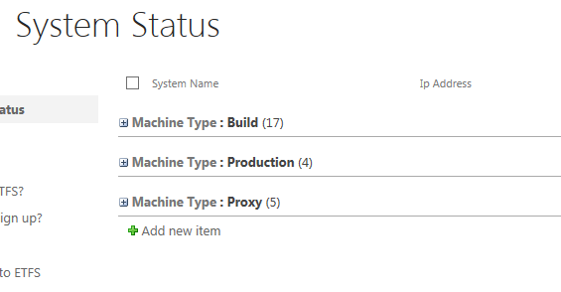

1. **Expand Proxy Servers. Review configuration column to make sure that the server is still in use.**

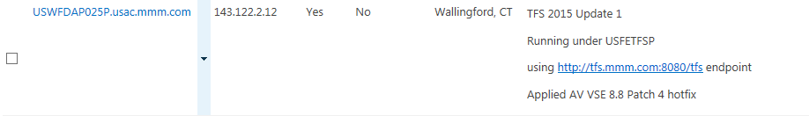

1. **Edit the proxy server record using the pull down menu on the server name. The information about the upgraded version will need to be updated.**

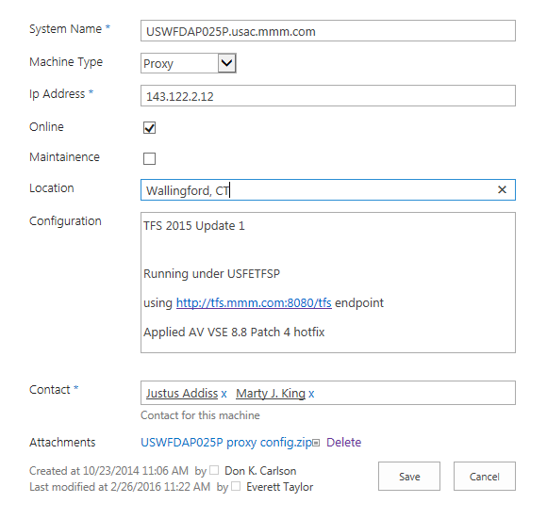

1. **Using the production TFSSETUP account (USFETFSSETUP), log on to the proxy server.**
2. **Locate media in file share location:** \\tfsbuildlab\etfs\Tools
3. **Copy media or upgrade package to D:\_tfs_data\Software. If a Software folder does not exist, create one. This is where you should store all TFS-related ISOs, patches, etc.**

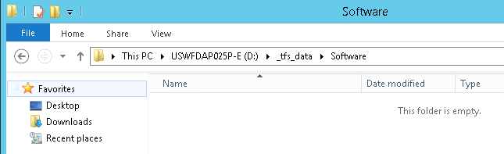

1. **Extract ISO to \_tfs_data\Software\[ISO name] if necessary.**
2. **There is no need to uninstall the previous version of the software first.**
3. **BEFORE doing the upgrade, capture the proxy statistics by using Internet Explorer (Run as Administrator) to navigate to:** <http://localhost:8081/VersionControlProxy/v1.0/ProxyStatistics.asmx>

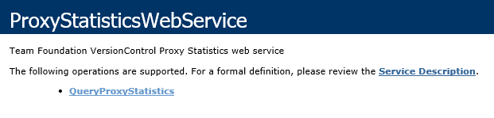

1. **Invoke QueryProxyStatistics.**

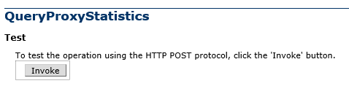

1. **Save response from web service call XML to temporary file in C:\Temp. Name is not important.**

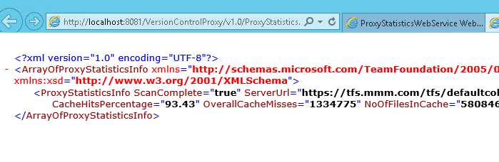

1. **Run setup.exe as Administrator.**

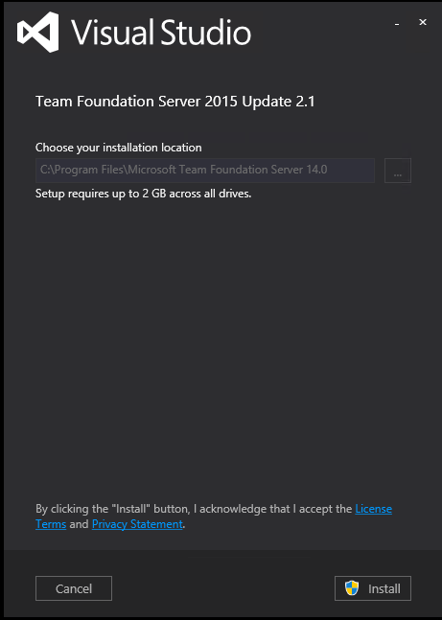

1. **Click Install to start installation. Make sure to uncheck any participation program checkboxes.**
2. **Wait for installation to finish.**
3. **From Configuration Center, select Configure Team Foundation Server Proxy. Start Wizard.**

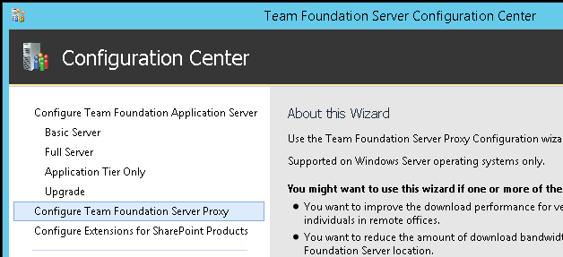

1. **If possible, keep existing configuration.**

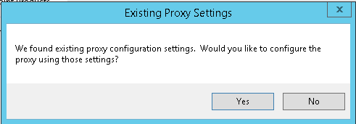

1. **Proxy endpoints should continue to point to production:**

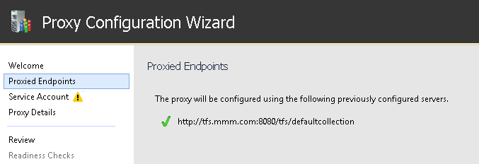

1. **Update the service account password for [TFSPROXY] account. You will need to retrieve the NPSA account password from the ETFS.kbdx KeePass file.**

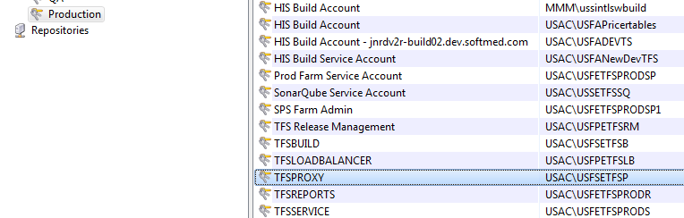

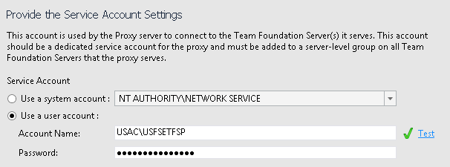

1. **Continue with standard cache folder location:**

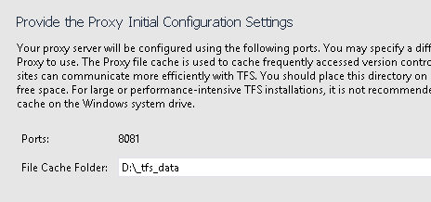

1. **Run readiness checks. You may see a warning about low disk space on the configured drive. If so, review the drive size remaining, and create an issue in TFS if the drive should be expanded. A good threshold is at least 20 GB open (not 50).**

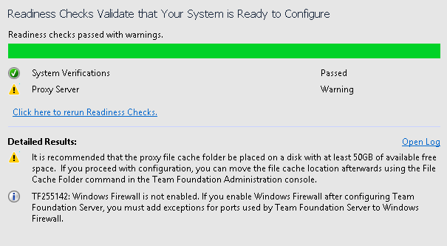

1. **Configure.**

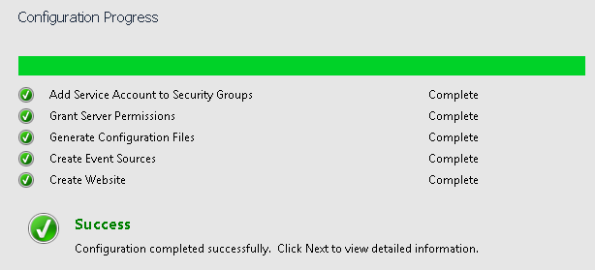

1. **Log onto another machine with Visual Studio installed.**
2. **Configure the proxy settings in Visual Studio to use this proxy server. This configuration may be set by going to $/etfs/config/proxy**

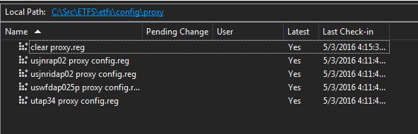

1. **Using the appropriate .reg file, merge the proxy settings into the registry.**
2. **Do a forced get operation to pull the $\etfs files through the proxy to your workstation. Keep it small, or you will wait forever.**
3. **Use Performance Monitor to watch the TFS Proxy Statistics to ensure that the proxy is handing out cached files.**

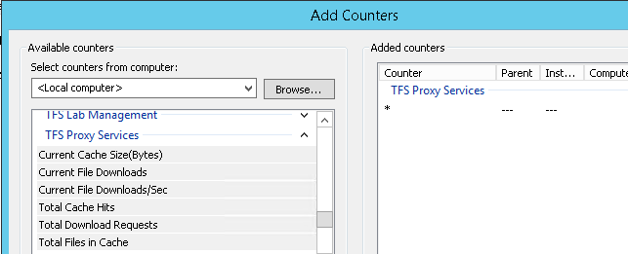

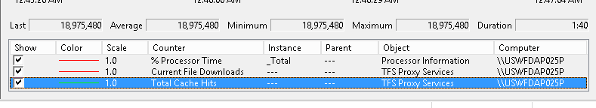

1. **Repeat Force Get and watch the cache hits. The number should go up.**
2. **Close Visual Studio.**
3. **Run “clear proxy.reg” from $/etfs/config/proxy to clear your workstation proxy configuration.**
4. **Clean up media from D:\_tfs_data folder.**
5. **Re-pin TFS Administration Console shortcut to taskbar.**
6. **Log off.**
7. **Update the information for the proxy server on the SharePoint page.**

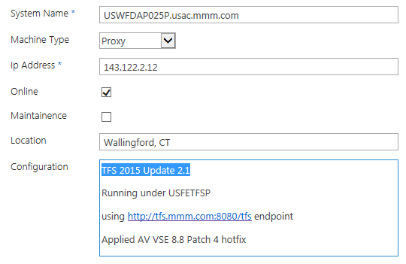

1. **Notify Manager on Duty that the upgrade is complete.**

**Upgrade Complete**

**Properties**

**Applies To: Team Foundation Server 2015**

**Date Created: 05/23/2016**

**Created By: Everett Taylor**

**Reviewed By: Vishwajeet Kumar**

**Last Updated: 05/24/2016**

**Updated By: Everett Taylor**